Inventory Optimization & Supply Chain Performance Analysis

1. Project Overview
The Inventory Optimization & Supply Chain Performance Analysis project was conducted to evaluate inventory efficiency, supply chain operations, warehouse utilization, supplier performance, and order fulfillment effectiveness. The objective was to identify operational bottlenecks, improve inventory management, reduce supply chain costs, and support data-driven decision-making through interactive Power BI dashboards.
The project involved data cleaning and analysis using industry-standard analytics practices and visualizing key supply chain KPIs through Power BI.

2. Business Problem
Organizations managing inventory across multiple warehouses often face challenges such as:
- Excess inventory leading to increased holding costs.
- Stock shortages resulting in backorders and lost sales.
- High transportation expenses impacting profitability.
- Delays in supplier deliveries and order fulfillment.
- Inefficient warehouse utilization.
- Limited visibility into supply chain performance.
The business required a centralized analytical solution to monitor supply chain KPIs and identify opportunities for operational improvement.

3. Dataset Overview
The dataset contains supply chain transaction records covering inventory, sales, warehouse operations, and supplier activities.

Dataset Summary
- Total Records: 1,200
- Total Columns: 15
- Time Period: 2020 – 2024

Key Fields

Inventory Metrics
- Inventory Level
- Average Inventory
- Warehouse Capacity

Sales Metrics
- Units Sold
- Cost of Goods Sold (COGS)

Supply Chain Metrics
- Transportation Cost
- Lead Time (Days)
- Order Accuracy
- Backorder Status

Business Dimensions
- Region
- Category
- Supplier
- Warehouse
- Order Status

4. Data Cleaning & Preparation
Several preprocessing steps were performed to ensure data quality and analytical readiness.

Data Validation
- Verified data types for numerical, categorical, and date fields.
- Checked for duplicate records.
- Standardized column formats and naming conventions.

Data Quality Checks
- Performed missing value analysis.
- No missing values were found in the dataset.
- Verified logical consistency across inventory and warehouse metrics.

Feature Preparation
- Converted date fields into time-based dimensions for trend analysis.
- Prepared measures for inventory utilization, order fulfillment, transportation costs, and warehouse performance.

5. Data Analysis
The dataset was analyzed to evaluate operational efficiency and supply chain performance.

Inventory Analysis
- Examined inventory levels across warehouses and product categories.
- Identified warehouses with higher stock concentrations.
- Compared average inventory against warehouse capacity.

Sales Performance Analysis
- Evaluated units sold by category and region.
- Analyzed contribution of product categories to overall business volume.
- Measured Cost of Goods Sold (COGS) across operational segments.

Supply Chain Analysis
- Assessed transportation cost patterns.
- Evaluated supplier lead times.
- Measured order fulfillment efficiency.

Warehouse Performance Analysis
- Compared warehouse utilization levels.
- Identified warehouses operating close to capacity.
- Monitored inventory distribution effectiveness.

Order Fulfillment Analysis
- Evaluated fulfilled, pending, and canceled orders.
- Measured order accuracy performance.
- Assessed impact of backorders on operations.

6. Dashboard Development (Power BI)
An interactive Power BI dashboard was developed to provide real-time visibility into supply chain operations.

Key KPIs
- Total Units Sold
- Average Inventory Level
- Transportation Cost
- Order Accuracy Rate
- Backorder Rate
- Warehouse Utilization
- Average Lead Time
- Total COGS

Dashboard Visualizations
- Inventory by Warehouse
- Inventory by Product Category
- Units Sold by Region
- Supplier Performance Analysis
- Transportation Cost Trends
- Lead Time Analysis
- Order Status Distribution
- Backorder Monitoring Dashboard
- Warehouse Capacity Utilization

Interactive Features
- Region Filters
- Supplier Filters
- Category Filters
- Warehouse Filters
- Time-Based Analysis

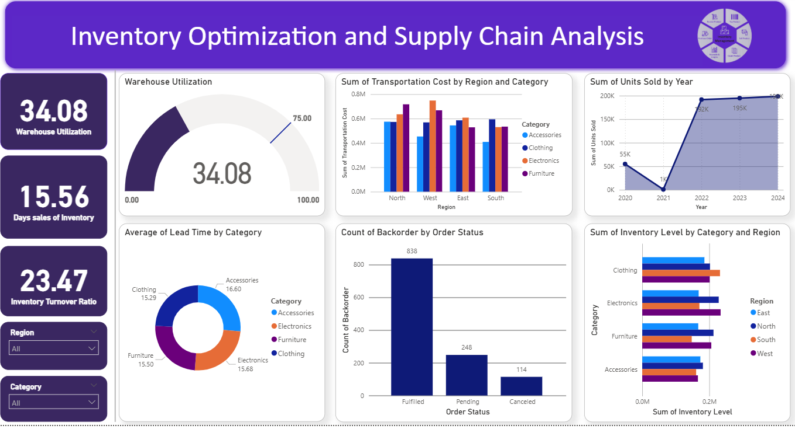

7. Key Insights

Inventory Insights
- Average inventory level was approximately 2,530 units.
- Inventory levels varied significantly across warehouses, indicating opportunities for inventory balancing.

Order Fulfillment Insights
- Approximately 69.8% of orders were successfully fulfilled.
- Around 20.7% of orders remained pending.
- Nearly 9.5% of orders were canceled, highlighting process improvement opportunities.

Supply Chain Insights
- Average lead time was approximately 16 days.
- Transportation costs represented a significant operational expense requiring optimization.

Service Quality Insights
- Order accuracy exceeded 91%, indicating strong operational execution.
- Backorders accounted for approximately 9.7% of transactions, suggesting occasional inventory shortages.

Warehouse Insights
- Warehouse capacity utilization varied across locations.
- Some warehouses maintained significantly higher inventory levels than others, indicating possible stock allocation inefficiencies.

8. Business Recommendations

1. Optimize Inventory Allocation
Redistribute inventory across warehouses to reduce stock imbalances and improve inventory turnover.

2. Reduce Backorders
Implement demand forecasting and safety stock strategies to minimize stock shortages and improve service levels.

3. Improve Supplier Performance
Monitor suppliers with longer lead times and establish performance benchmarks to ensure timely replenishment.

4. Optimize Transportation Costs
Analyze shipping routes and logistics partners to reduce transportation expenses and improve delivery efficiency.

5. Improve Order Fulfillment
Investigate causes of pending and canceled orders to increase fulfillment rates and enhance customer satisfaction.

6. Enhance Warehouse Utilization
Monitor warehouse capacity utilization and optimize storage allocation to improve operational efficiency.

7. Implement Predictive Analytics
Use forecasting models to anticipate demand fluctuations and support proactive inventory planning.

8. Establish KPI Monitoring Framework
Continuously track inventory turnover, lead time, fulfillment rate, transportation cost, and backorder metrics through Power BI dashboards.

9. Conclusion
The Inventory Optimization & Supply Chain Performance Analysis project provided valuable visibility into inventory management, warehouse operations, supplier performance, and order fulfillment processes. Through data-driven insights and Power BI visualizations, the organization can improve operational efficiency, reduce costs, minimize backorders, and strengthen overall supply chain performance.

